**Innovation, Employability Professional Readiness for**

**and Entrepreneurship**

ASSIGNMENT 1

SMART HOME

Submitted by,

Adalin V

Reg No. 961819106003

Batch:- B12-6A2E

SMART HOME

CODE FOR SMART HOME:-

void setup()

{

Serial.begin(9600);

pinMode(13,OUTPUT); //LED lights in the room

pinMode(3,INPUT); //ECHO in ultrasonic

pinMode(2,OUTPUT); //TRIGGER in ultrasonic

pinMode(12,OUTPUT); //Buzzer for temperature

}

void loop()

{

digitalWrite(2,0);

digitalWrite(2,1);

delay(1000);

digitalWrite(2,0);

float dur=pulseIn(3,1);

float dis=(dur*0.0343)/2;

digitalWrite(13,0);

if (dis<20){

Serial.print("Distance: ");

Serial.print(dis);

Serial.println(" cm");

digitalWrite(13,1);

double a=analogRead(A0);

double t=(((a/1024) *5)-0.5) *100;

Serial.print("Temperature: ");

Serial.println(t);

delay(1000);

if (t>100){

for(int j=130;j<150;j++)

{

tone(12,j);

}

delay(10000);

noTone(12);

}

}

delay(1000);

}

CIRCUIT DIAGRAM FOR SMART HOME:-

Tinker cad link: <https://www.tinkercad.com/things/f44PCswSleJ-smart-home>

SNAPS OF SMART HOME:-

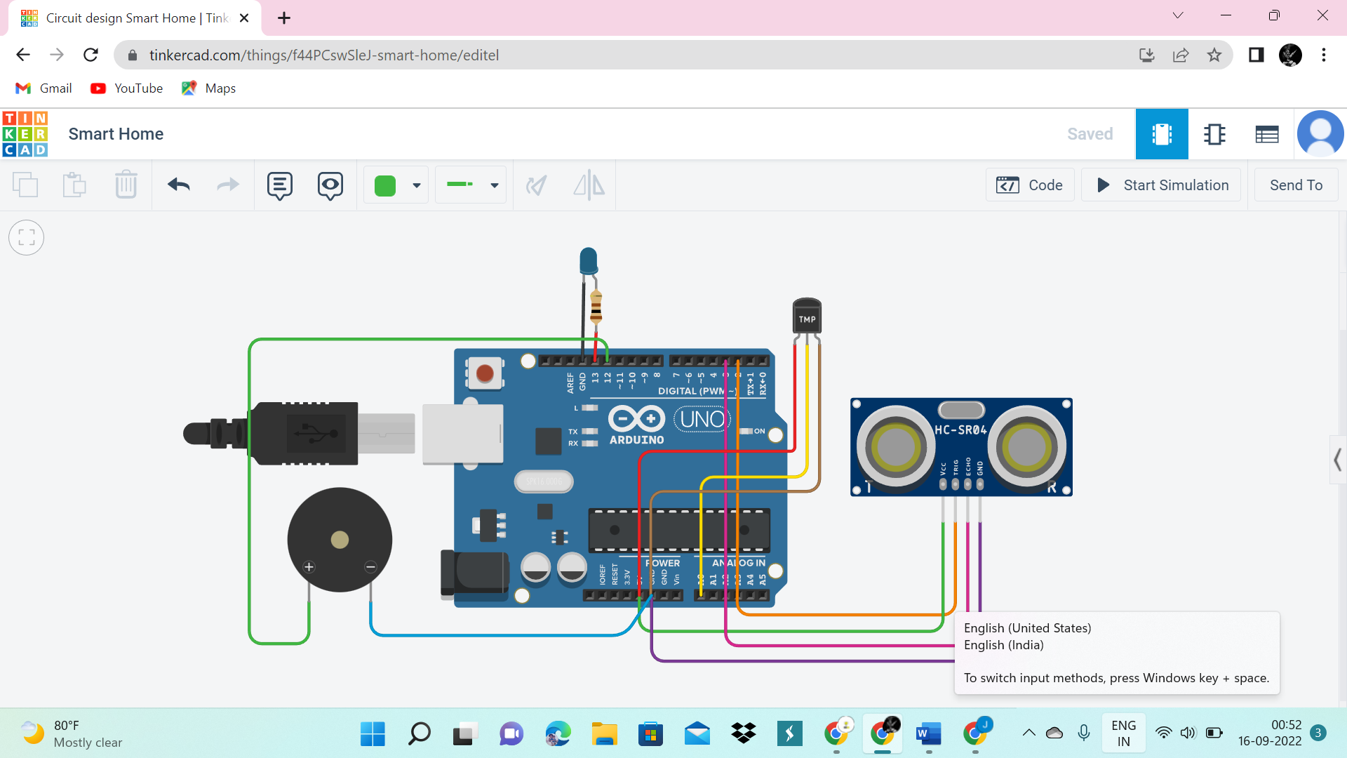

The above circuit describes the Smart home application

using ultrasonic sensor and temperature sensor . Ultrasonic sensor is used to calculate the distance from an object . If a man entering close to ultrasonic sensor ,the light ( LED ) Connected to pinmode 13 gets ON and if a man leave from that appropriate distance the lights get OFF . And when the temperature in a home is detected high the buzzer in pinmode 12 gets on , to detect the high temperature that may be a fire also. Hence , the power consumption in a home can be saved .